Highly Stereoselective Decarboxylation of (+)-1-Bromo-1-chloro-2,2,2-trifluoropropanoic Acid gives (+)-1-Bromo-1-chloro-2,2,2-trifluoroethane ((+)-Halothane) with Retention of Configuration

Olga Lavinda, David J. Szalda, Keith Ramig*

Department of Natural Sciences, Baruch College, the City University of New York, 17 Lexington Ave., New York, New York 10010

Supporting Information
Table of Contents
Nr. | Title | Page
1. | Computational Methodology | S3
2. | References for Computational Methodology | S4
3. | Cartesian coordinates, number of imaginary frequencies and energies for the structures involved in the inversion of anion 10 at PCM-B3LYP/6-31++G** | S6
4. | Cartesian coordinates, number of imaginary frequencies and energies for the structures involved in the inversion of anion 11 at PCM-B3LYP/6-31++G** | S8
5. | Enthalpies of activation for anions 10 and 11 at PCM-B3LYP/6-31++G**, PCM-B3LYP/6-311++G** and PCM-B3LYP/aug-cc-pVDZ including Temperature parameter. | S10

1. Computational Methodology
In this study, calculations were carried out using B3LYP¹ hybrid functional in Gaussian09² software package using 6-31++G** basis set. Results were confirmed with 6-311++G** and aug-cc-pVDZ basis sets. Pople’s³ 6-31++G** and 6-311++G** basis sets have been shown to well reproduce experimental geometries in a range of molecules.⁴ Due to the presence of two sets of diffuse valence basis atomic orbitals, they satisfy the requirement for calculating anions, which calls for a use of more diffuse functions, as well as high computational efficiency.⁵ For comparison, the results were confirmed using Dunning’s⁶ aug-cc-pVDZ that was shown to overestimate the bond lengths and energies,⁴ but has been chosen for its consistency in anionic systems.
All stationary points were characterized as being either minima or maxima by harmonic frequency analysis. All first-order saddle points had one imaginary frequency and the local minima had zero negative frequencies. The reaction pathways were confirmed by the internal reaction coordinate (IRC)⁷ analysis. Reported enthalpies include unscaled zero-point energy (ZPE) corrections that were calculated with the same method and basis set. Structures reported in the manuscript were visualized using GaussView⁸ software.
In attempt to reproduce experimental reactions carried out in this work, we used Polarizable Continuum Model (PCM)⁹ for introducing solvents. In the case of the DMPU/TEG mixture, solvent mixture was specified by using generic command alongside with PCMDoc followed by the experimental parameters, which were combined assuming linearity.¹⁰ Additionally, we included a temperature parameter in accordance with the experiment.
There exist multiple rotamers of anion 10 which differ by the position of the OMe group relative to the lone pair. In our theoretical study we considered two major conformers 10A and 10B (Fig S1) in which the position of the OMe group differs by approximately 180º. Analysis determined that 10A conformer is more stable than 10B by 3.8 kcal/mol, which is in agreement with findings of Polavarapu et al.¹¹ who used vibrational circular dichroism for studies of 1,2,2,2,-tetrafluoroethyl methyl ether 7. They determined that trans-conformer corresponding to conformation of 10A is dominant by 78%, while the g- conformer, is less stable and is present at 22% at B3LYP/6-31G* level of theory.

Figure S1. Conformers of 2¹¹ and anion 10.

2. References for Computational Methodology
1. (a) Becke, A. D. J. Chem. Phys. 1993, 98, 1372-1377. (b) Becke, A. D. J. Chem. Phys. 1993, 98, 5648-5652. (c) Lee, C.; Yang, W.; Parr, R. G. Phys. Rev. B 1988, 37, 785-789. (d) Stephens, P. J.; Devlin, F. J.; Chabalowski, C. F.; Frisch, M. J. J. Phys. Chem. 1994, 98, 11623-11627.
2. Frisch, M. J., Trucks, G. W., Schlegel, H. B., Scuseria, G. E., Robb, M. A., Cheeseman, J. R., Scalmani, G., Barone, V., Mennucci, B., Petersson, G. A., Nakatsuji, H., Caricato, M., Li, X., Hratchian, H. P., Izmaylov, A. F., Bloino, J., Zheng, G., Sonnenberg, J. L., Hada, M., Ehara, M., Toyota, K., Fukuda, R., Hasegawa, J., Ishida, M., Nakajima, T., Honda, Y., Kitao, O., Nakai, H., Vreven, T., Montgomery, Jr., J. A., Peralta, J. E., Ogliaro, F., Bearpark, M., Heyd, J. J., Brothers, E., Kudin, K. N., Staroverov, V. N., Kobayashi, R., Normand, J., Raghavachari, K., Rendell, A., Burant, J. C., Iyengar, S. S., Tomasi, J., Cossi, M., Rega, N., Millam, N. J., Klene, M., Knox, J. E., Cross, J. B., Bakken, V., Adamo, C., Jaramillo, J., Gomperts, R., Stratmann, R. E., Yazyev, O., Austin, A. J., Cammi, R., Pomelli, C., Ochterski, J. W., Martin, R. L., Morokuma, K., Zakrzewski, V. G., Voth, G. A., Salvador, P., Dannenberg, J. J., Dapprich, S., Daniels, A. D., Farkas, Ö., Foresman, J. B., Ortiz, J. V., Cioslowski, J., Fox, D. J. (2009) Gaussian, Inc., Wallingford CT.
3. Hehre, W. J.; Random, L.; Schleyer, P. v. R.; Pople, J. A. Ab Initio Molecular Orbital Theory; Wiley: New York, 1986.
4. Wiberg, K. B. J. Comput. Chem. 2003, 25, 1342–1346.
5. Simmons, J. J. Phys. Chem. A 2008, 112, 6401–6511.
6. Dunning, T. H., Jr. J Chem Phys 1989, 90, 1007.
7. (a) Fukui, K. Acc. Chem Res. 1981, 14, 363-368 (b) Gonzalez, C.; Schlegel, H. B. J. Phys. Chem. 1990, 94, 5523-5527.
8. GaussView, Version 5, Dennington, R.; Keith, T.; Millam, J. Semichem Inc., Shawnee Mission KS, 2009.
9. Tomasi, J.; Mennucci, B.; Cammi, R. Chem. Rev., 2005, 105, 2999-3093.
10. Fox, J.; Scalmani, G. Gaussian, Inc, private communication, 2011.
11. Polavarapu, P. L.; Zhao, C.; Ramig, K. Tetrahedron: Asymmetry 1999, 10, 1099-1106.
3. Cartesian coordinates, number of imaginary frequencies and energies for the structures involved in the inversion of anion 10 at PCM-B3LYP/6-31++G**

Reactant 10

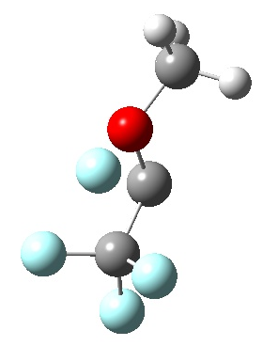
0 imaginary frequencies

Zero-point correction= 0.061651 (Hartree/Particle)
Thermal correction to Energy= 0.079033
Thermal correction to Enthalpy= 0.080531
Thermal correction to Gibbs Free Energy= 0.001318
Sum of electronic and zero-point Energies= -590.762612
Sum of electronic and thermal Energies= -590.745231
Sum of electronic and thermal Enthalpies= -590.743732
Sum of electronic and thermal Free Energies= -590.822945

-1 1
C 0.47053500 0.31816300 -0.48326100
O 1.36956700 -0.32876000 0.37367200
C 2.69065700 -0.44731900 -0.15160700
H 3.16008800 0.53703700 -0.26784100
H 3.26746800 -1.03625600 0.56734200
H 2.67838800 -0.95562300 -1.12296700
C -0.88791000 -0.17306500 -0.06366700
F -1.05729900 -1.48933700 -0.39719000
F -1.89426200 0.51454600 -0.68171400
F -1.21425900 -0.11367800 1.28850400
F 0.42113400 1.74383100 0.01543300

Transition State 10 – β-elimination
(Displacement vectors show direction of atom movement during elimination)

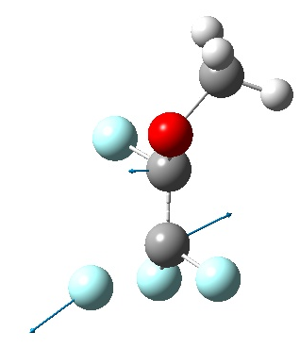
1 imaginary frequency

Zero-point correction= 0.060735 (Hartree/Particle)
Thermal correction to Energy= 0.077861
Thermal correction to Enthalpy= 0.079359
Thermal correction to Gibbs Free Energy= 0.000022
Sum of electronic and zero-point Energies= -590.751326
Sum of electronic and thermal Energies= -590.734199
Sum of electronic and thermal Enthalpies= -590.732701
Sum of electronic and thermal Free Energies= -590.812038

-1 1
C 0.48574000 0.35301600 -0.20944300
F -1.66377200 -0.22483400 1.33909300
F -1.75220300 0.59293600 -0.84359400
F -0.95957300 -1.44600300 -0.53116500
F 0.53328400 1.74832000 0.06572900
O 1.42458300 -0.32460400 0.51943300
C 2.68486800 -0.50411100 -0.15013100
H 3.15500200 0.46278000 -0.35903700
H 3.31901200 -1.07793700 0.52925800
H 2.54441800 -1.05452100 -1.08642900
C -0.80972900 -0.14344700 -0.22539600

4. Cartesian coordinates, number of imaginary frequencies and energies for the structures involved in the inversion of anion 11 at PCM-B3LYP/6-31++G**

Reactant 11

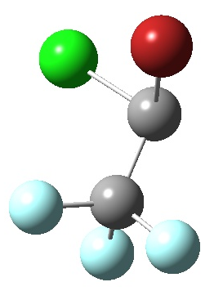
0 imaginary frequencies

Zero-point correction= 0.018647 (Hartree/Particle)
Thermal correction to Energy= 0.028576
Thermal correction to Enthalpy= 0.029735
Thermal correction to Gibbs Free Energy= -0.024691
Sum of electronic and zero-point Energies= -3407.760724
Sum of electronic and thermal Energies= -3407.750795
Sum of electronic and thermal Enthalpies= -3407.749636
Sum of electronic and thermal Free Energies= -3407.804062

-1 1
C -0.14916900 0.34727100 -0.70214700
Cl -0.43009800 2.03573600 0.01542000
Br 1.64029100 -0.27960400 0.00727800
C -1.17023600 -0.54295800 -0.05068300
F -1.24831700 -0.60972100 1.33417300
F -1.00642500 -1.83783800 -0.45009900
F -2.43215400 -0.17991600 -0.43961700

30º Rotamer of Anion 11
(Displacement vectors show direction of atom movement during rotation of CF₃)

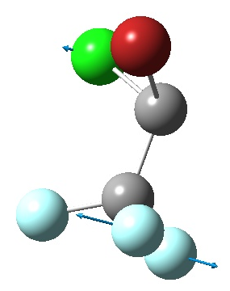

0 imaginary frequencies

Zero-point correction= 0.018462 (Hartree/Particle)
Thermal correction to Energy= 0.030531
Thermal correction to Enthalpy= 0.031838
Thermal correction to Gibbs Free Energy= -0.033827
Sum of electronic and zero-point Energies= -3407.754169
Sum of electronic and thermal Energies= -3407.742101
Sum of electronic and thermal Enthalpies= -3407.740793
Sum of electronic and thermal Free Energies= -3407.806458

-1 1
C -0.12908300 0.35813000 -0.62868500
Cl -0.38261000 2.05116100 0.01791700
Br 1.65899500 -0.30654100 0.00520900
C -1.19844800 -0.52849500 -0.05897900
F -0.81305200 -1.82741100 0.06118700
F -2.31564100 -0.51853100 -0.86015400
F -1.71522700 -0.22279500 1.20330700

Transition State – inversion of asymmetric carbon in anion 11
(Displacement vectors show direction of atom movement during inversion)

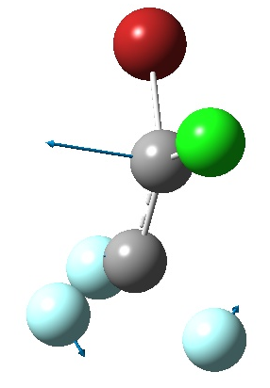
1 imaginary frequency

Zero-point correction= 0.017755 (Hartree/Particle)
Thermal correction to Energy= 0.027240
Thermal correction to Enthalpy= 0.028399
Thermal correction to Gibbs Free Energy= -0.025456
Sum of electronic and zero-point Energies= -3407.743089
Sum of electronic and thermal Energies= -3407.733605
Sum of electronic and thermal Enthalpies= -3407.732446
Sum of electronic and thermal Free Energies= -3407.786301

-1 1
Cl 0.27481000 2.07284700 0.00003200
C 0.06940400 0.32187900 0.00043800
Br -1.70193300 -0.35262600 0.00001500
C 1.20674100 -0.48797600 -0.00006000
F 2.15271800 -0.30416300 -1.08604500
F 2.15291000 -0.30527400 1.08625300
F 0.94315200 -1.82388700 -0.00057700

5. Enthalpies of activation for anions 10 and 11 at PCM-B3LYP/6-31++G**, PCM-B3LYP/6-311++G** and PCM-B3LYP/aug-cc-pVDZ including Temperature parameter.

 | B3LYP /6-31++G** | B3LYP/6-311++G** | B3LYP/aug-cc-pVDZ
10 ΔH≠_{elimination} | 6.35 kcal/mol | 5.29 kcal/mol | 6.24 kcal/mol
11 ΔH≠ _{inversion} | 10.23 kcal/mol | 10.01 kcal/mol | 11.24 kcal/mol

